**Design and Implementation of a Full Model Hindlimb Model of a Rat**

**Fletcher Young**

# Abstract

The purpose of this work is to develop a hindlimb muscle model to better understand the hierarchical control structure of reflex modulation. This model will use information from the literature to estimate parameters for all muscles in the hindlimb. Using optimization techniques and the hindlimb model, known torque profiles will be deconstructed into muscle force profiles.

To better understand how output kinematics are dictated by underlying neural structures, this work will:

**Aim 1 - Expand a neuromechanical model of a rat hindlimb to include a complete musculature with physiological muscle paths.** Muscle paths from the literature will be incorporated into a three-dimensional model of the rat hindlimb. Model kinematics will be compared to hindlimb models in the literature to demonstrate efficacy.

**Aim 2 – Investigate muscle activation strategies that meet torque demands under nominal and perturbed conditions.** Muscle model parameters will be developed from physiological measurements in the literature. Experimental measurements for joint motion and torque measurements will be used to calculate muscle forces. Muscle forces will then be converted to muscle activation profiles that will be organized and compared for different locomotion situations.

**Aim 3 – Create novel simulation tools for neuromechanical simulations focused on large-scale neural network design.** A novel simulation tool will be developed to specifically aid the construction of large-scale neural networks using recently developed design approaches. This work will use open source materials to allow for further development as the field matures. Novel simulation tools will be used to recreate work from past aims and compare output metrics.

Contents

Abstract 0

Motivation 2

Modeling Considerations 3

A Walking Rat Model: Previous Project Developments 5

Methods for Neural Modeling: Synergies 7

Perturbations 8

Aim 1 - Expand a neuromechanical model of a rat hindlimb to include a complete musculature with physiological muscle paths 9

Completed Work 9

Publications 12

Aim 2 – Investigate muscle activation strategies that meet torque demands under nominal and perturbed conditions 12

Background 12

Aim 2 Remaining Work: Optimizing Hill Parameters 20

Aim 2 Remaining Work: Modeled EMGs 21

Aim 3 – Create novel simulation tools for neuromechanical simulations focused on large-scale neural network design 22

Motivation 22

Aim 3 Remaining Work: A Novel Neuromechanical Simulation Package 24

References 25

# Motivation

Animals are better suited than robots to address walking hazards, suggesting that a biologically-inspired control system could be an effective foundation for robotic control. Understanding the exact mechanisms that animals use to coordinate hierarchical sensorimotor pathways requires invasive experimentation that can impede the natural performance of the system. Biomechanical models have been developed to better understand the complex interplay of the nervous and body systems. Sufficiently sophisticated biomechanical modeling tools must be created to address the wealth of biological data as it increases with further experimentation. This work discusses the development of a biomechanical model through the lens of simulation tools which could aid in future model development.

The growing inclusion of biomechanics in robotic design emphasizes the importance of incorporating principles of “living machines” into product development. Roboticists are beginning to incorporate musculature in these robots and even integrating biological control systems to coordinate them (Sharbafi et al. 2016; Luo et al. 2018). Studies have been done on many types of locomotion such as swimming (Weeks and Jr 1978), flying (Chung and Dorothy 2010), or undulating (Bryden and Cohen 2008). Robots inspired by insects have exploited the inherent stability of alternating tripod gaits (Beer et al. 1997; Szczecinski, Brown, et al. 2014). Rat locomotion has been studied extensively and replicated in simulation (Morrison 1970; Witte et al. 2002; Fischer et al. 2002; Andrada et al. 2013). Legged locomotion is a preferable modality for environments navigated by humans but its complexity necessitates sophisticated processing methods and robust actuators.

# Modeling Considerations

Quality biomechanical models can provide insight into how animals “work” but effective models must consider all relevant systems for insight into adaptive behavior. Three broad systems interplay to determine an animal’s emergent behavior: the environment in which the animal exists, the body that the animal uses to manipulate itself or the environment, and the nervous system that the animal uses to control the body. Complex feedback mechanisms between these layers exist, with the nervous system controlling the body using neural “suggestions” rather than “demands”, issuing generalized commands that are contingent on the states of the body and environment (Chiel and Beer 1997). The simultaneous development of feedback mechanisms between these interconnected systems are lost when considering any system in isolation (Chiel et al. 2009). Developing biomechanical models that accurately emulate emergent behavior resulting from the intertwined nervous and body systems is contingent on simulating their interaction with environmental factors as realistically as possible.

Understanding the activity of the nervous system is a complex process due to its highly nonlinear relationship with the body and environment. Recently, a novel neural design approach has been developed that compartmentalizes groups of neurons into algebraic subunits, called functional subnetworks (FSN) (Szczecinski, Hunt, and Quinn 2017a). Networks designed using the FSN approach include known functional relationships when morphological components are not fully understood. Decomposing larger systems into modular components allows for iterative network development as new biological structures are studied. FSN design has been used to control locomotion in robots modeled after a dog (Hunt, Szczecinski, and Quinn 2017; Szczecinski, Hunt, and Quinn 2017b) and a praying mantis (Szczecinski, Martin, et al. 2014).

One tool used to develop biomechanical models is Animatlab, a simulation program that includes both a physics engine and a neural design environment (Cofer et al. 2010). Animatlab allows researchers to simultaneously design organs and the neurons that innervate them. This tool is an asset for testing neural configurations and rapidly prototyping novel control schemes based on new discoveries. The use of this program, chiefly as it relates to modeling the layers of emergent behavior, will be discussed as it relates to a model of rat locomotion.

# A Walking Rat Model: Previous Project Developments

This work discusses advancements made to a model developed by Dr. Alexander Hunt in completion of a doctoral thesis (Hunt et al. 2014; 2015; Hunt 2016). In Hunt's work, an artificial neural network coordinated hindlimb muscle contractions on an articulated biomechanical rat model in a simulated environment. Joints were controlled by discrete subunits known as central pattern generators (CPGs), bilateral neural subnetworks which oscillate in the presence of a constant input. CPGs have been used extensively in models that control locomotion (Beer, Chiel, and Gallagher 1999; Ijspeert 2008; Chung and Dorothy 2010; Schrade et al. 2017; Duysens and Forner-Cordero 2019; Dutta et al. 2019). Hunt’s model is a useful example of the multi-layer modeling that is crucial to understanding emergent behavior. However, the modeling practices used to coordinate its locomotion rely on a number of simplifications that must be addressed in order to design a model that falls more in line with a living animal.

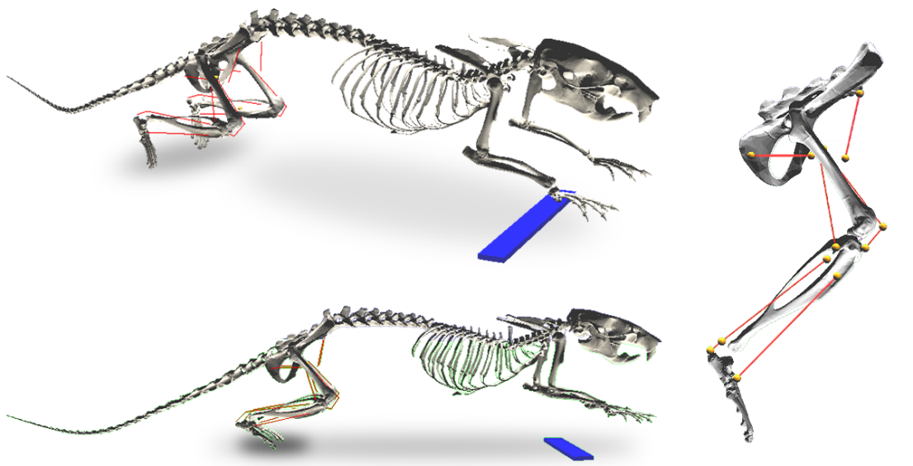

Figure 1 The rat model used by Hunt for modeling locomotion. Note the antagonistic muscle pairs at each joint. The blue bar represents a solid support that raises the static torso above the ground while moving.

Hunt’s model incorporated a hierarchical CPG system inspired by work from McCrae and Rybak’s work in a cat model to coordinate joint motion (McCrea and Rybak 2008). Neural control of locomotion is abstracted into hierarchical layers composed of CPGs with a high order rhythm generator (RG) layer and a low level pattern formation (PF) layer. Hunt’s model has a discrete PF unit at each joint, oscillating between flexion and extension. This simplification is useful because it allows for a one-to-one connection between the CPG half centers (bilateral neurons with alternating activation) but lacks a distribution method for accommodating the inclusion of more muscles.

An animal’s ability to generate propulsive and stabilizing limb forces is dependent on a complex interplay of muscle lines of action across multiple joints. Hunt’s model excludes muscles which span multiple joints, known as biarticular muscles (Cleland 1867). While monoarticular muscles primarily generate forces along the length of a bone segment, biarticular muscles are critical for generating transverse forces (Hof 2001). Utilizing the multi-level CPG hierarchy of McCrae and Rybak, a one-to-one connection between half-center neurons in the CPG and antagonistic muscles was possible. The inclusion of biarticular muscles introduces a design challenge when considering how a discrete, joint based control system can be generalized to coordinate contractions of muscles whose activity is not exclusive to a single joint. Work has already begun to address this design challenge through neural control but has not yet integrated a complete muscle set (Deng et al. 2019).

# Methods for Neural Modeling: Synergies

Organizing muscles into groups whose contractions have temporal and spatial correlations, referred to as “muscle synergies”, is a biologically representative method of improving the computational efficiency of a control system (W. A. Lee 1984; Tresch, Saltiel, and Bizzi 1999). Implementing a synergy-based neural control system could accelerate optimization techniques necessary for the implementation of the FSN method by reducing the dimensionality of the parameter space that the nervous system must control (Ting and Macpherson 2005; Aoi et al. 2013; Alessandro, Carbajal, and d’Avella 2014). Muscle synergy analysis has broad uses including viability in clinical, robotic, and sport analysis (Taborri, Agostini, et al. 2018; Steele, Rozumalski, and Schwartz 2015).

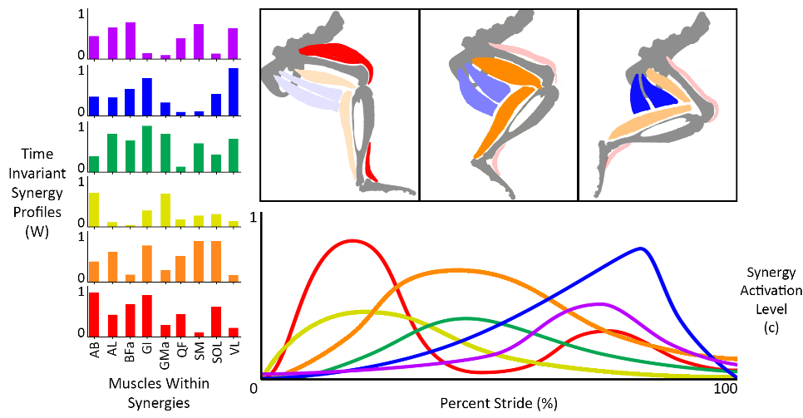

Figure 2 A conceptual example of synergy decomposition. Time invariant synergy profiles represent relative muscle activations. Synergy activation levels represent temporal activation of entire synergy groups.

Statistical methods are used to identify muscle synergies by decomposing electromyography (EMG) measurements from many muscles while completing a task. Multiple matrix factorization techniques have been used to characterize synergy profiles (Andrea d’Avella, Saltiel, and Bizzi 2003; Tresch, Cheung, and d’Avella 2006; Torres-Oviedo and Ting 2007; Taborri, Palermo, et al. 2018), with the most common being nonnegative matrix factorization (NNMF) (Ting et al. 2012; D. D. Lee and Seung 2001). In NNMF, rectified, low-pass filtered EMG recordings are decomposed into a set of spatial vectors, representing time invariant muscle activation profiles, and temporal vectors, representing the timing of synergy coactivation. The overall muscle activation characterizes the relative activation of muscles in the hindlimb at a point in time and determines the kinetics that the leg produces.

The synergy model has recently come under scrutiny as researchers have posited that synergies are less likely manifestations of physical neural systems and moreso optimal task-specific responses from the body (Perreault et al. 2008; Tresch and Jarc 2009; Kutch and Valero-Cuevas 2011). The task-specific focus of muscle synergy derivation does not mean that the model is unsuitable for robotic control, though, so long as the natural dynamics of the systems are considered within the task demands (A. d’Avella and Bizzi 2005; Berniker et al. 2009).

# Perturbations

Nominal walking patterns are kinematic profiles (joint angles, torque patterns, muscle activation, etc.) that describe limb motion during unimpeded flat ground walking at a self-selected speed. The development of nominal models are useful because they are relatively easy to create and there is a wealth of nominal metrics available in the literature. Ultimately, nominal patterns reveal little about the dynamic interplay between the nervous system, body, and environment because they fail to activate afferent feedback pathways that respond to environmental uncertainty. Adding perturbations to kinematic responses, such as obstacles to jump over or holes to fall into, trigger different actions. Analyzing these reflexes, as they manifest in joint kinematics and muscle EMG patterns, can suggest new pathways in the hierarchical structure of walking systems.

## Aim 1 - Expand a neuromechanical model of a rat hindlimb to include a complete musculature with physiological muscle paths

### Completed Work

*Muscle Attachment Points*

A hindlimb model with a redundant muscle set is necessary to study the impact of muscle grouping on control schemes. Initially, I used muscle attachment point clouds with xyz-coordinates for the origins and insertions of all muscles for the rat hindlimb (Will L. Johnson et al. 2008) and presented the resulting model at Living Machines 2018 (Young, Hunt, and Quinn 2018). After further analysis of the modeling software it became apparent that Johnson’s xyz-coordinates were unusable because they did not include coordinates for “via” points, points along the muscle line of action that are necessary to simulate muscle wrapping. Additionally, Johnson’s work provided coordinates within bone-centric coordinate systems with axes based on poorly defined bony landmarks that were impossible to accurately identify on the bone meshes.

Rather than adapting Johnson’s point clouds onto the bone meshes, I decided to hand-guide the muscle lines of action based on anatomical drawings and descriptions from E.C. Greene’s 1955 publication Anatomy of the Rat (Greene 1955). This work provides detailed descriptions of muscle attachment points relative to bone structures, neighboring muscles, and tendons as well as muscle paths around bones. Due to limitations in the simulation software, it is only possible to represent muscles as lines of action with origin, insertion, and via points. For muscles with lines of attachment (such as the gluteus maximus running along the dorsal border of the ilium), a single attachment point was placed approximately halfway along the line of attachment.

Figure 3 An example of using Greene's anatomical drawings to guide the muscle paths in Animatlab

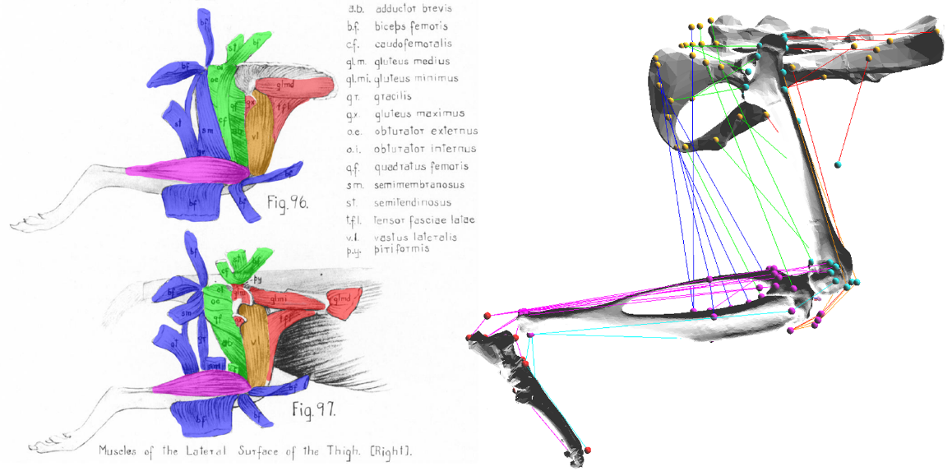

*Dynamic Muscle Moment Arm Profiles*

The functional effect that a muscle has about a joint can be understood by analyzing its moment arm profile about that joint (Visser et al. 1990; S. W. Lee et al. 2008; Williams et al. 2008; Yeo et al. 2011; Charles et al. 2016). In small animals, measuring muscle moment arms is especially important because small changes in the placement of muscle attachment points can dramatically affect a muscle’s torque generating capabilities. Moment arm profiles are a useful metric whereby a model can be validated against existing hindlimb models.

I implemented two joint motion protocols in Animatlab to analyze muscle moment arm profiles across a range of joint motions. First, I implemented a protocol that moved each joint independently through its entire range of motion between limits as defined by Fischer et al (Fischer et al. 2002). Muscle moment arms gathered from the full range of motion protocol were compared to two hindlimb models that had analyzed moment arm profiles in the sagittal plane (W. L. Johnson et al. 2011; Charles et al. 2016). Second, I implemented a nominal walking protocol, as defined by Fischer et al., to create 3D moment arm profiles for biarticular muscles. The nominal walking protocol illustrated the complex relationship that multi-joint motion has on the mechanical advantage of biarticular muscles, a property that is excluded in traditional 2D, single joint moment arm profiles.

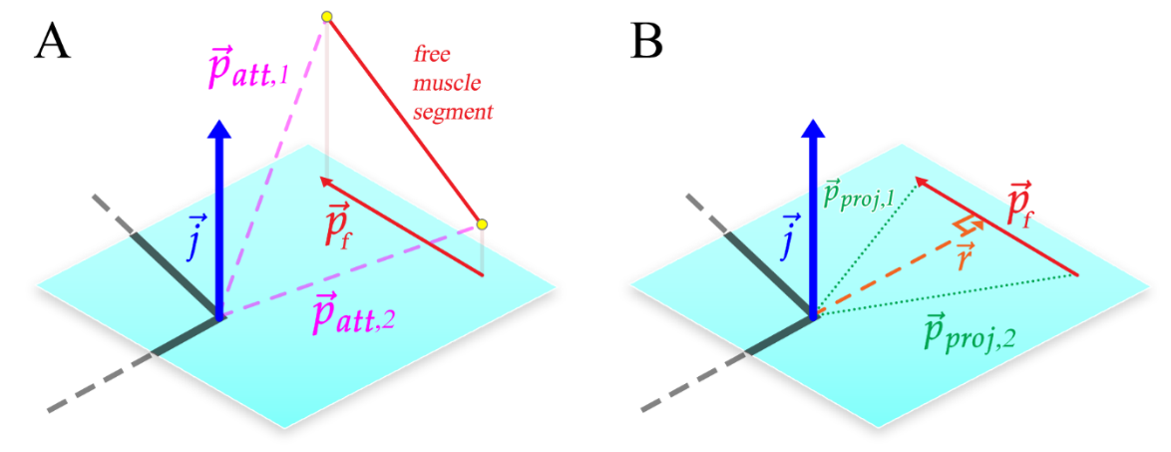

Figure 4 Calculating the muscle moment arm, r. The plane of interest and its coordinate system is defined by the joint center and the joint axis representing flexion/extension (blue). Joint axes are defined using the same convention as Charles and Johnson. Orthogonal joint axes represent abduction/adduction, and inversion/eversion. The free muscle segment that connects the adjacent bone segments (monoarticular muscles) or to the bone segment after the next (biarticular muscles) is projected onto the plane of interest. This projected free segment is called. The muscle moment arm, the signed magnitude of , is calculated from  and  as described in the text.

I calculated moment arm profiles for the model by projecting muscle paths onto the sagittal plane and measuring the shortest distance from the joint center to the free muscle segment. The “free” muscle segment is the muscle portion between attachment points in different bone coordinate systems that undergoes length change as a joint is moved. In addition to calculating moment arm profiles, a sensitivity analysis was conducted to examine the impact of muscle attachment point placement on sagittal plane moment arm profiles. This work is discussed in detail in a paper published in the Journal of Biomimetics (Young et al. 2019)**.**

### Publications

1. Young, F., Rode, C., Hunt, A. & Quinn, R. Analyzing Moment Arm Profiles in a Full-Muscle Rat Hindlimb Model. *Biomimetics* **4**, 10 (2019).
2. Young, F., Hunt, A. J. & Quinn, R. D. A Neuromechanical Rat Model with a Complete Set of Hind Limb Muscles. in *Biomimetic and Biohybrid Systems* 527–537 (Springer, 2018).

## Aim 2 – Investigate muscle activation strategies that meet torque demands under nominal and perturbed conditions

### Background

Animatlab uses a two-compartment linear Hill muscle model (Hill Archibald Vivian 1938) for representing tension. This model, shown in Figure XXX5, is characterized by an elastic element in series with a contractile-elastic element. The series elastic element, kse, represents the force-length properties of the muscle while the contractile-elastic element captures the force-velocity components of the muscle. Work by Zajac (Zajac 1989) has formalized Hill’s model into an equation used by Animatlab,

,

where T is muscle tension, $k_{SE}$ is serial element stiffness, $k_{PE}$ is parallel element stiffness, L is muscle length, c is the muscle damping factor,$A_{m}$ is muscle activation in Newtons, and $A_{l}$ is a dimensionless length-tension modifier.

Figure 5 The linear Hill muscle model used by Animatlab.

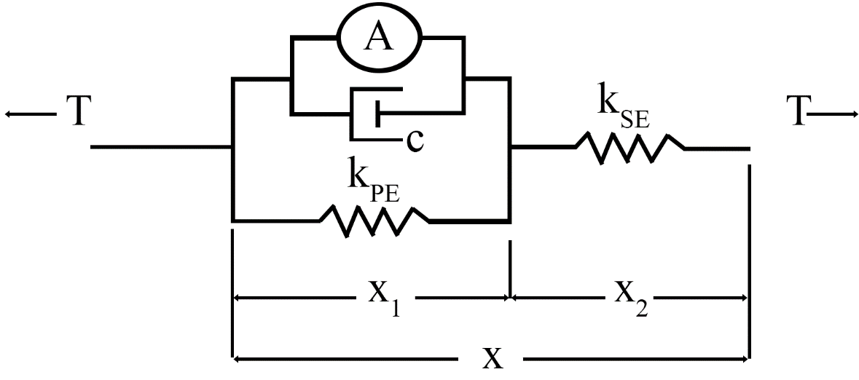

I have not found any work that calculates Hill muscle parameters for every muscle in the rat hindlimb. Work by Johnson et al. (W. L. Johnson et al. 2011) and Eng et al. (Eng et al. 2008) have described physiological parameters (muscle mass, optimal muscle length, etc.) for rat hindlimb muscles. By combining the physiological parameters from Johnson and Eng with the modeling equations from Zajac, it is possible to approximate Hill muscle parameters for an Animatlab model. Hill parameters were determined by specifying relationships between the muscle length, stimulus, and tension.

Two relationships define muscle force generating properties in Animatlab: the length-tension curve and the stimulus-tension curve. The length-tension (LT) curve relates a muscle’s force-generating capabilities at various isometric lengths. At a unique “optimal” length, a muscle is able to generate a maximal amount of force. Deviations from the optimal length lessen the muscle’s ability to generate force. The stimulus-tension (ST) curve relates muscle membrane potential to muscle force output. Strong activation of a muscle’s motorneuron induces strong contractions.

* + - * 1. **Completed Work: The LT curve**

Animatlab uses a simplified LT curve equation,

,

where L is the muscle length,  is the percent of maximal tension at a specific length, Lwidth is the muscle width, and Lrest is the resting muscle length. Zajac’s generalized muscle model relates normalized muscle length to normalized muscle force. Zajac’s generalizes LT curve is shown in Figure XXX6B. Following the form of Zajac’s generalized LT curve, the muscle generates zero force when it is at 50% and 150% the optimal muscle length. I represented this information using Animatlab’s inverted parabola equation above, choosing a muscle width that is half the resting length to match Zajac’s generalized curve.

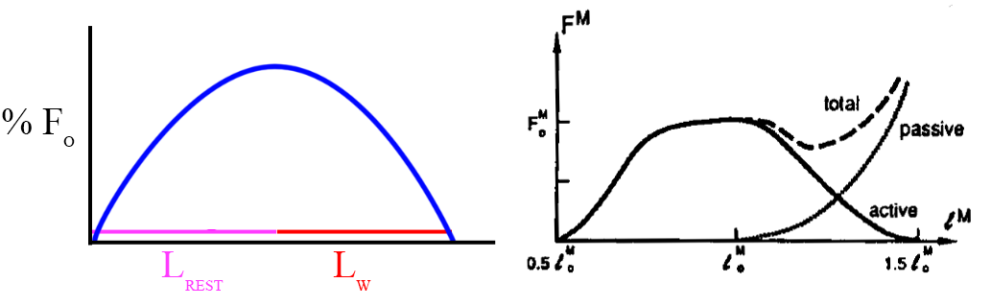

Figure 6 Animatlaband Zajac's LT curves

I decided to create LT curves similar to Zajac’s generalized curve, shown in Figure XXX7. With this curve, I was able to calculate kpe, kse, and Am values for each muscle in the system. This was done by solving the Hill tension equations at steady state with optimal length and tensions values from Johnson (W. L. Johnson et al. 2011). Using the steady state Hill equation, the equilibrium () force relationship becomes,

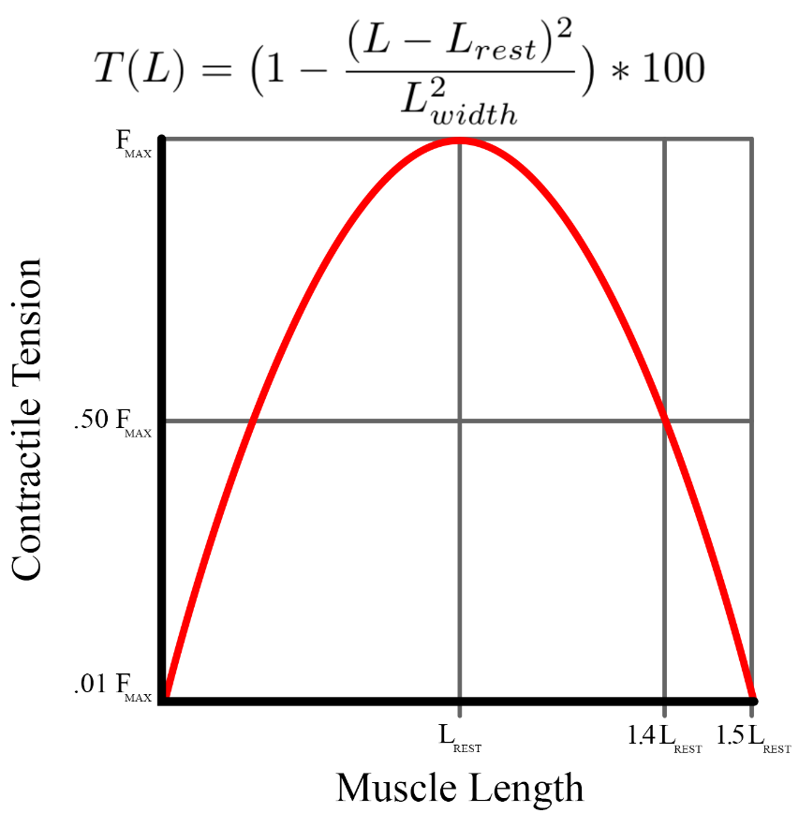

Figure 7 The length-tension curve as modeled by Animatlab

.

I found solutions to the steady state equation at three force-length points to find values of kse, kpe, and Am using Matlab’s function solver. The solution set with all positive values and  closest to  was chosen for each muscle and injected into an Animatlab project file. Animatlab’s LT curve fails to capture the asymmetry of the LT curve about the resting length.

* + - * 1. 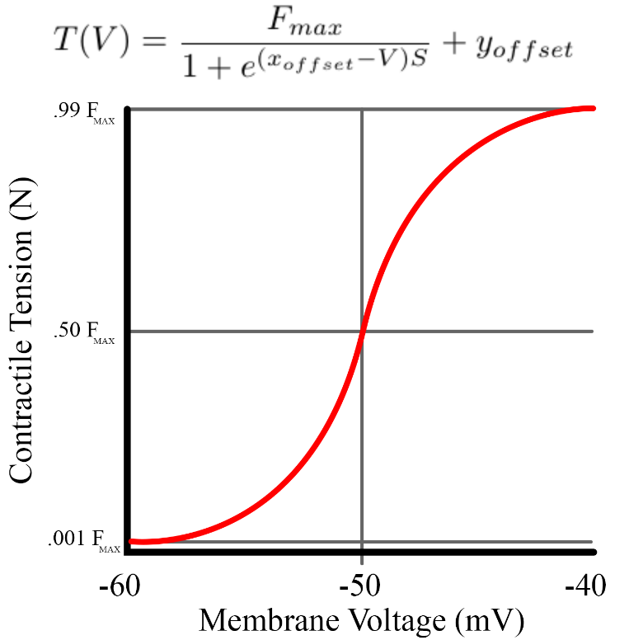**Completed Work: The Stimulus-Tension (ST) Curve**

Figure 8 The ST curve as modeled in Animatlab. Steepness was calculated to meet the boundary conditions described in the text.

Animatlab uses a simplified ST equation,

,

where  is the tension at a specific motorneuron voltage in Newtons, Fmax is the maximum muscle force, xoffset is the offset for the sigmoid, yoffset is the force offset for the sigmoid, V is the motorneuron voltage, and S is the steepness of the curve.

The Animatlab rat models use a neural design process that reduces complex networks into functional subnetworks (FSN) that coordinate locomotion (Szczecinski, Hunt, and Quinn 2017a). Since FSN models are composed of neurons with an operating range of -60 to -40mV, the ST curve is centered around -50mV. The muscle is almost completely deactivated at -60mV and generating maximum force output at -40mV. From these boundary conditions, I calculated the slope of the sigmoid.

Animatlab’s ST curve fails to capture many of the nuances associated with the stimulation mechanics of muscles, such as twitch mechanics (Spector et al. 1980) or the time delay between EMG signal onset and measured force (Buchanan et al. 2004; Corcos et al. 1992).

* + - * 1. **Completed Work: Passive Torque**

Stance phase torque profiles were measured for rats walking on inclined and flat surfaces (Andrada et al. 2013) and swing phase torque profiles were modeled by Hunt in simulation (Hunt et al. 2014). Stance and swing phase torque profiles were then interpolated to create a nominal torque profile for the entire stride, which is currently used in the simulation. I use the torque profiles generated by Hunt to distribute muscle forces based on the calculated moment arm profiles described above.

I have calculated passive joint torque from two sources: the passive forces of the muscles and the body weight of the animal. Passive muscle force is only generated when the muscle length is extended beyond the resting muscle length. This force is calculated by evaluating the Hill equation without stimulus. I calculated passive muscle torque for each joint during stride as the sum of passive muscle forces times the muscle moment arms about the joint.

Passive joint torque also manifests from the body weight of the animal during walking. I approximated this value by treating the leg as a multi-segment arm and using the ground reaction forces (GRFs) to calculate the induced joint torque. Passive torque from body weight was calculated by computing the spatial manipulator Jacobian, an operator for converting end effector forces into torques at the joints (Murray, Li, and Sastry 1994). GRFs were generated from the three dimensional data from Muir et al. (Muir and Whishaw 1999).

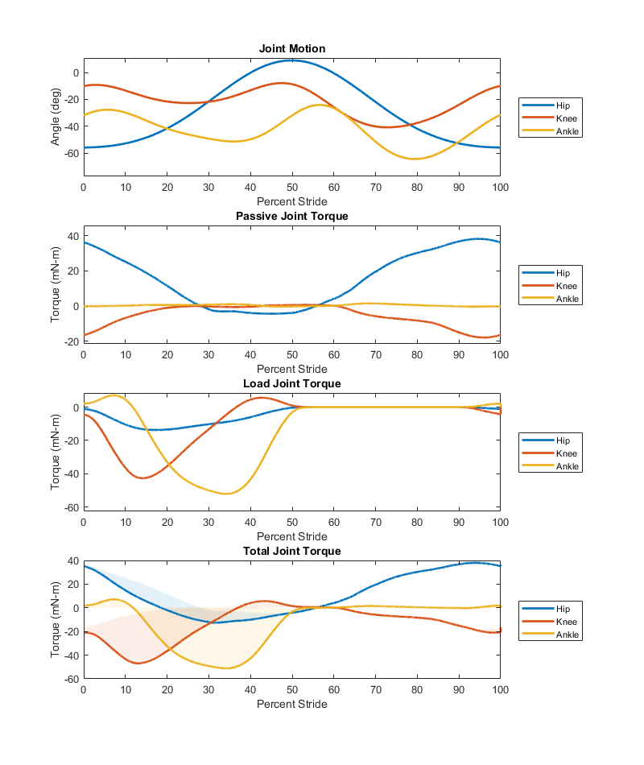

Figure 9 Joint torque generated by motion defined by the top subplot. Passive joint torque is generated by the muscle passive properties. Load joint torque is generated by the weight of the animal as it comes in contact with the ground (only during stance). The total joint torque is shown in the bottom plot with shaded regions indicating the impact of load torque on the passive muscle torque waveforms.

* + - * 1. **Completed Work: Implemented Multiple Optimization Functions**

A number of different optimization criteria have been tested to distribute muscle forces in an effort to parse the infinite solution space created by joint torque profiles. Previous approaches minimize cumulative muscle parameters such as force (Pedotti, Krishnan, and Stark 1978; Penrod, Davy, and Singh 1974), stress (Crowninshield and Brand 1981), activation (Kaufman et al. 1991), and fatigue (Prilutsky and Zatsiorsky 2002). These optimization methods have been analyzed as models of force sharing in cat hindlimbs where it was shown that no single method is able to perfectly recreate experimental results (Herzog and Leonard 1991).

Initially, I applied linear optimization at each time step during a single stride by minimizing the summed forces. Although torque profile is comprised of a linear combination of muscle torque, linear optimization methods generate solutions that fall on what Crowninshield et al. refers to as an “optimization corner” of the solution space, causing jagged force profiles that are not indicative of actual muscle contractions.

I have evaluated force distribution results from multiple cost functions from Pedotti et al. and Seireg et al. (Seireg and Arvikar 1973), including linear and nonlinear cost functions. The results of this analysis is shown in figure XXX10, with the most suitable cost function appearing to be from Pedotti et al. relating muscle forces to their maximum values squared.

### Aim 2 Remaining Work: Optimizing Hill Parameters

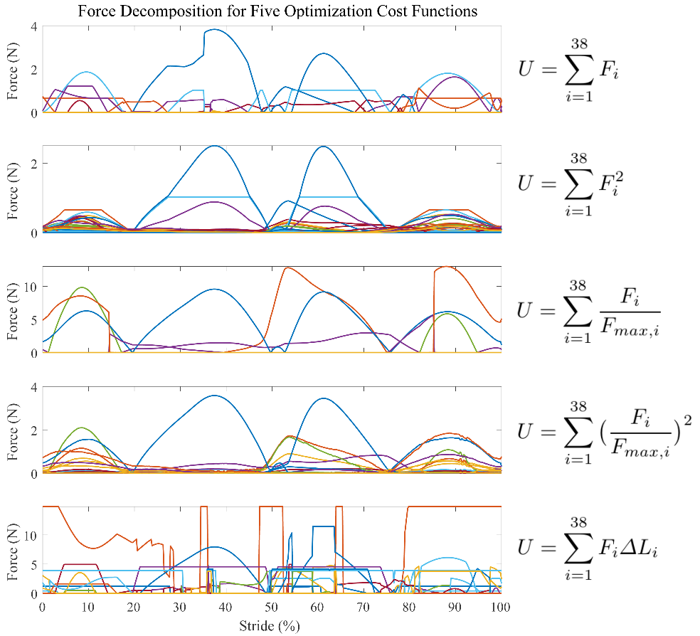

Figure 10 Force profiles as a result of using five different optimization cost functions. In all instances, the cost function, **U**, is minimized while maintaining the torque demands of the system.

I’m interested in refining the muscle parameters I’ve developed to better match experimental results. I would like to write a paper that explores the Hill parameter space for all muscles in the hindlimb, comparing the Hill tension equation with experimental results. This work could be incredibly useful for future hindlimb modeling, akin to the work that Johnson has compiled for his hindlimb model. A number of models use Hill muscles in their work but very few discuss the parameter calculations, underlying assumptions, or whether their models match experimental results.

To advance this work, I need access to force measurements or EMG data from as many hindlimb muscles as possible. I can then compare muscle tension waveforms with my predicted Hill parameter in order to optimize my results.

Now that muscle force profiles have been developed through optimization, the ST curve equation can be solved to find the neural stimulation necessary to induce the forces. Work by Thelen and Lloyd suggest nonlinear relationships between activation and EMG signals. The underlying EMG signals that elicit these forces can be compared to muscle recordings gathered by research collaborators.

### Aim 2 Remaining Work: Modeled EMGs

Now that I have calculated muscle force profiles, I can formulate the nonlinear relationships between activation and EMG signals as established by Thelen et al., Lloyd et al., and Buchanan et al. To advance this work, I would compare the resulting EMG signals with EMG data from the rat to determine which optimization method produced the most accurate waveforms for a walking model.

## Aim 3 – Create novel simulation tools for neuromechanical simulations focused on large-scale neural network design

### Motivation

As the rat model becomes more complex through the addition of muscles, the nervous system must grow to accommodate them. Hunt's model, which only utilized six muscles and had one-to-one muscle-to-CPG connections, used over 40 neurons. A model that features thirty-eight muscles per leg, many of which are biarticular, will require a more comprehensive method of system building than simply building by hand. As the FSN design approach matures and its implementation in neuromechanical models becomes more widespread, the ability to automate FSN design becomes more and more critical.

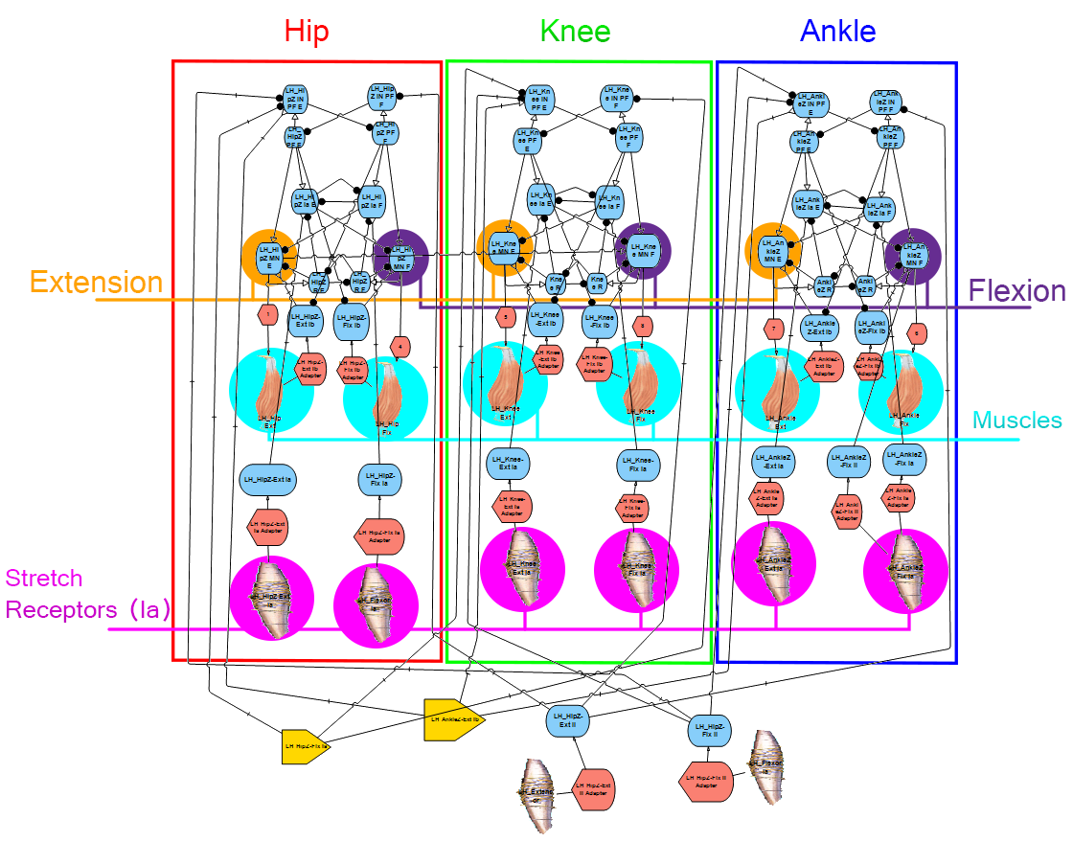

Figure 11 The FSN of Hunt's model. This model is broken into three discrete joint sections which are subdivided into flexion/extension halves. As the musculature of the system scales up, this system becomes much more complex.

As touched upon previously, Animatlab has a number of setbacks as a simulation tool. For work that uses FSN approaches in kinematic models, it is imperative to use a simulation package that includes both a neural interface and a physics environment. As noted by Chiel et al. (Chiel and Beer 1997), understanding adaptive behavior requires the analysis of both the nervous system and the body.

Animatlab is no longer supported by the developer which makes its functionality under software updates increasingly unlikely. The program is compiled in the C programming language which makes it difficult to understand what is happening "under the hood" of the program or to make modifications. Additionally, navigating the user interface is tenuous when expanding the size of a nervous system and lacks basic functionality such as an "undo" button. In the physics module, it is impossible to wrap muscles around bone, prevent muscle pass-through, or create muscle insertion lines along surfaces. The basic principles underlying the FSN approach are sound and ripe for research development but the field will soon outgrow Animatlab.

Animatlab has a number of constraints when it comes to developing a truly robust muscle model. The LT and ST curves are reductive because they do not take into account some interesting features of muscle, such as the asymmetrical lengthening/shortening profile of the force velocity curve (Murphy and Beardsley 1974; Yeo et al. 2011) or the impact of tendon tension on force magnitudes (Pearlman, Roach, and Valero-Cuevas 2004). I have studied a number of muscle models (Thelen 2003; Brown, Scott, and Loeb 1996; Lloyd and Besier 2003) over the course of parameter development to better understand how different force relationships combine to form an overall force profile.

Additionally, the process for uploading information from Matlab into Animatlab for simulation is a hindrance. For stimulus waveforms, this process involves creating a sum of sines approximation of waveforms and then injecting that equation into an Animatlab file in the form of a tonic stimulus. Approximations sometimes differ from the activation waveforms and the process of editing text documents with Matlab can be tedious.

Other common simulation programs for locomotion research include OpenSim (Seth et al. 2011) and even the 3D computer graphics software Blender. However, these alternatives lack a built-in neural design environment that is fundamental to developing neural systems for the underlying control of muscles.

The final aim of this thesis would be to integrate the kinematic work of the previous aims with the synthetic nervous system design paradigm established in prior work. Models of the nervous system pale in comparison to the actual nervous system of vertebrates, with reduced numbers of neurons and abstractions from their nonlinear nature to ease computational costs. Many models exist of purely neural systems, but the creation of neural controlled physics structures would make for a unique modeling tool that could benefit many research projects.

### Aim 3 Remaining Work: A Novel Neuromechanical Simulation Package

Alternatives for Animatlab must be developed to advance the field of FSN design. As a first step in creating a UI alternative, a Matlab project has been developed that allows users to automatically generate FSN subsystems to expedite system design. An FSN "toolbox", where the synaptic connections are automatically calculated, allows users to generate large-scale networks with minimal effort. This program, called Canvas, allows for nervous system design and component editing but still requires users to export the system into an Animatlab file. This is a valuable first step to understanding how Animatlab formats information and what information is necessary for the creation of an alternative program.

While useful for analyzing and processing data, Matlab is a proprietary software with limited user engagement. Although functionality is expanding, the program was not created to handle the types of user interaction necessary to rival software like Animatlab. For this reason, it’s necessary to consider alternatives for developing neuromechanical simulators.

Python is a programming language with a wealth of community resources for project development and has been deployed in millions of research and commercial projects. Most notably, Python contains a repository of open-source packages related to creating things in physics environments and generating GUI's. An Animatlab alternative developed in Python would be an asset to the field of FSN design and ease the design process for future generations of FSN researchers. This aim would revolve around creating a functional Animatlab alternative in Python and testing its use on the rat model to address persistent research questions.

The result of this aim would be a design publication similar to Cofer et al. that describes a novel neuromechanical design package developed in Python. This work would serve as a baseline for development that could be expanded by future work either at Case or other institutions.

# References

Alessandro, Cristiano, Juan Pablo Carbajal, and Andrea d’Avella. 2014. “A Computational Analysis of Motor Synergies by Dynamic Response Decomposition.” *Frontiers in Computational Neuroscience* 7. https://doi.org/10.3389/fncom.2013.00191.

Andrada, E., J. Mämpel, A. Schmidt, M.S. Fischer, A. Karguth, and H. Witte. 2013. “From Biomechanics of Rats’ Inclined Locomotion to a Climbing Robot.” *International Journal of Design & Nature and Ecodynamics* 8 (3): 192–212. https://doi.org/10.2495/DNE-V8-N3-192-212.

Aoi, Shinya, Takahiro Kondo, Naohiro Hayashi, Dai Yanagihara, Sho Aoki, Hiroshi Yamaura, Naomichi Ogihara, et al. 2013. “Contributions of Phase Resetting and Interlimb Coordination to the Adaptive Control of Hindlimb Obstacle Avoidance during Locomotion in Rats: A Simulation Study.” *Biological Cybernetics* 107 (2): 201–16. https://doi.org/10.1007/s00422-013-0546-6.

Avella, A. d’, and E. Bizzi. 2005. “Shared and Specific Muscle Synergies in Natural Motor Behaviors.” *Proceedings of the National Academy of Sciences* 102 (8): 3076–81. https://doi.org/10.1073/pnas.0500199102.

Avella, Andrea d’, Philippe Saltiel, and Emilio Bizzi. 2003. “Combinations of Muscle Synergies in the Construction of a Natural Motor Behavior.” *Nature Neuroscience* 6 (3): 300–308. https://doi.org/10.1038/nn1010.

Beer, Randall D., Hillel J. Chiel, and John C. Gallagher. 1999. “Evolution and Analysis of Model CPGs for Walking: II. General Principles and Individual Variability.” *Journal of Computational Neuroscience* 7 (2): 119–47. https://doi.org/10.1023/A:1008920021246.

Beer, Randall D., Roger D. Quinn, Hillel J. Chiel, and Roy E. Ritzmann. 1997. “Biologically Inspired Approaches to Robotics: What Can We Learn from Insects?” *Commun. ACM* 40 (3): 30–38. https://doi.org/10.1145/245108.245118.

Berniker, Max, Anthony Jarc, Emilio Bizzi, and Matthew C. Tresch. 2009. “Simplified and Effective Motor Control Based on Muscle Synergies to Exploit Musculoskeletal Dynamics.” *Proceedings of the National Academy of Sciences*, April, 6. https://doi.org/10.1073/pnas.0901512106.

Brown, Ian E., Stephen H. Scott, and Gerald E. Loeb. 1996. “Mechanics of Feline Soleus: II Design and Validation of a Mathematical Model.” *Journal of Muscle Research & Cell Motility* 17 (2): 221–33. https://doi.org/10.1007/BF00124244.

Bryden, John, and Netta Cohen. 2008. “Neural Control of Caenorhabditis Elegans Forward Locomotion: The Role of Sensory Feedback.” *Biological Cybernetics* 98 (4): 339–51. https://doi.org/10.1007/s00422-008-0212-6.

Buchanan, Thomas S., David G. Lloyd, Kurt Manal, and Thor F. Besier. 2004. “Neuromusculoskeletal Modeling: Estimation of Muscle Forces and Joint Moments and Movements From Measurements of Neural Command.” *Journal of Applied Biomechanics* 20 (4): 367–95.

Charles, James P., Ornella Cappellari, Andrew J. Spence, Dominic J. Wells, and John R. Hutchinson. 2016. “Muscle Moment Arms and Sensitivity Analysis of a Mouse Hindlimb Musculoskeletal Model.” *Journal of Anatomy* 229 (4): 514–35. https://doi.org/10.1111/joa.12461.

Chiel, Hillel J., and Randall D. Beer. 1997. “The Brain Has a Body: Adaptive Behavior Emerges from Interactions of Nervous System, Body and Environment.” *Trends in Neurosciences* 20 (12): 553–57. https://doi.org/10.1016/S0166-2236(97)01149-1.

Chiel, Hillel J., Lena H. Ting, Örjan Ekeberg, and Mitra J. Z. Hartmann. 2009. “The Brain in Its Body: Motor Control and Sensing in a Biomechanical Context.” *Journal of Neuroscience* 29 (41): 12807–14. https://doi.org/10.1523/JNEUROSCI.3338-09.2009.

Chung, Soon-Jo, and Michael Dorothy. 2010. “Neurobiologically Inspired Control of Engineered Flapping Flight.” *Journal of Guidance, Control, and Dynamics* 33 (2): 440–53. https://doi.org/10.2514/1.45311.

Cleland, John. 1867. “On the Actions of Muscles Passing over More than One Joint.” *Journal of Anatomy and Physiology* 1 (1): 85–93.

Cofer, David, Gennady Cymbalyuk, James Reid, Ying Zhu, William J. Heitler, and Donald H. Edwards. 2010. “AnimatLab: A 3D Graphics Environment for Neuromechanical Simulations.” *Journal of Neuroscience Methods* 187 (2): 280–88. https://doi.org/10.1016/j.jneumeth.2010.01.005.

Corcos, Daniel M., Gerald L. Gottlieb, Mark L. Latash, Gil L. Almeida, and Gyan C. Agarwal. 1992. “Electromechanical Delay: An Experimental Artifact.” *Journal of Electromyography and Kinesiology* 2 (2): 59–68. https://doi.org/10.1016/1050-6411(92)90017-D.

Crowninshield, Roy D., and Richard A. Brand. 1981. “A Physiologically Based Criterion of Muscle Force Prediction in Locomotion.” *Journal of Biomechanics* 14 (11): 793–801. https://doi.org/10.1016/0021-9290(81)90035-X.

Deng, Kaiyu, Nicholas S. Szczecinski, Dirk Arnold, Emanuel Andrada, Martin S. Fischer, Roger D. Quinn, and Alexander J. Hunt. 2019. “Neuromechanical Model of Rat Hindlimb Walking with Two-Layer CPGs.” *Biomimetics* 4 (1): 21. https://doi.org/10.3390/biomimetics4010021.

Dutta, Sourav, Abhinav Parihar, Abhishek Khanna, Jorge Gomez, Wriddhi Chakraborty, Matthew Jerry, Benjamin Grisafe, Arijit Raychowdhury, and Suman Datta. 2019. “Programmable Coupled Oscillators for Synchronized Locomotion.” *Nature Communications* 10 (1): 1–10. https://doi.org/10.1038/s41467-019-11198-6.

Duysens, Jacques, and Arturo Forner-Cordero. 2019. “A Controller Perspective on Biological Gait Control: Reflexes and Central Pattern Generators.” *Annual Reviews in Control*, April. https://doi.org/10.1016/j.arcontrol.2019.04.004.

Eng, Carolyn M., Laura H. Smallwood, Maria Pia Rainiero, Michele Lahey, Samuel R. Ward, and Richard L. Lieber. 2008. “Scaling of Muscle Architecture and Fiber Types in the Rat Hindlimb.” *Journal of Experimental Biology* 211 (14): 2336–45. https://doi.org/10.1242/jeb.017640.

Fischer, Martin S., Nadja Schilling, Manuela Schmidt, Dieter Haarhaus, and Hartmut Witte. 2002. “Basic Limb Kinematics of Small Therian Mammals.” *Journal of Experimental Biology* 205 (9): 1315–38.

Greene, E. C. 1955. *Anatomy of the Rat.* New York: Hafner Publishing Co. https://www.cabdirect.org/cabdirect/abstract/19561405416.

Herzog, W., and T. R. Leonard. 1991. “Validation of Optimization Models That Estimate the Forces Exerted by Synergistic Muscles.” *Journal of Biomechanics*, Proceedings of the NASA Symposium on the Influence of Gravity and Activity on Muscle and Bone, 24 (January): 31–39. https://doi.org/10.1016/0021-9290(91)90375-W.

Hill Archibald Vivian. 1938. “The Heat of Shortening and the Dynamic Constants of Muscle.” *Proceedings of the Royal Society of London. Series B - Biological Sciences* 126 (843): 136–95. https://doi.org/10.1098/rspb.1938.0050.

Hof, A. L. 2001. “The Force Resulting from the Action of Mono- and Biarticular Muscles in a Limb.” *Journal of Biomechanics* 34 (8): 1085–89. https://doi.org/10.1016/S0021-9290(01)00056-2.

Hunt, Alexander. 2016. “Neurologically Based Control for Quadruped Walking.” Cleveland, OH: Case Western Reserve University.

Hunt, Alexander, Manuela Schmidt, Martin Fischer, and Roger D. Quinn. 2014. “Neuromechanical Simulation of an Inter-Leg Controller for Tetrapod Coordination.” In *Biomimetic and Biohybrid Systems*, edited by Armin Duff, Nathan F. Lepora, Anna Mura, Tony J. Prescott, and Paul F. M. J. Verschure, 142–53. Lecture Notes in Computer Science. Springer International Publishing.

Hunt, Alexander, Nicholas Szczecinski, and Roger Quinn. 2017. “Development and Training of a Neural Controller for Hind Leg Walking in a Dog Robot.” *Frontiers in Neurorobotics* 11. https://doi.org/10.3389/fnbot.2017.00018.

Hunt, Alexander, Nicholas S. Szczecinski, Emanuel Andrada, Martin Fischer, and Roger D. Quinn. 2015. “Using Animal Data and Neural Dynamics to Reverse Engineer a Neuromechanical Rat Model.” In *Biomimetic and Biohybrid Systems*, edited by Stuart P. Wilson, Paul F.M.J. Verschure, Anna Mura, and Tony J. Prescott, 211–22. Lecture Notes in Computer Science. Springer International Publishing.

Ijspeert, Auke Jan. 2008. “Central Pattern Generators for Locomotion Control in Animals and Robots: A Review.” *Neural Networks*, Robotics and Neuroscience, 21 (4): 642–53. https://doi.org/10.1016/j.neunet.2008.03.014.

Johnson, W. L., D. L. Jindrich, H. Zhong, R. R. Roy, and V. R. Edgerton. 2011. “Application of a Rat Hindlimb Model: A Prediction of Force Spaces Reachable Through Stimulation of Nerve Fascicles.” *IEEE Transactions on Biomedical Engineering* 58 (12): 3328–38. https://doi.org/10.1109/TBME.2011.2106784.

Johnson, Will L., Devin L. Jindrich, Roland R. Roy, and V. Reggie Edgerton. 2008. “A Three-Dimensional Model of the Rat Hindlimb: Musculoskeletal Geometry and Muscle Moment Arms.” *Journal of Biomechanics* 41 (3): 610–19. https://doi.org/10.1016/j.jbiomech.2007.10.004.

Kaufman, K. R., K. -N. An, W. J. Litchy, and E. Y. S. Chao. 1991. “Physiological Prediction of Muscle Forces—I. Theoretical Formulation.” *Neuroscience* 40 (3): 781–92. https://doi.org/10.1016/0306-4522(91)90012-D.

Kutch, Jason J., and Francisco J. Valero-Cuevas. 2011. “Muscle Redundancy Does Not Imply Robustness to Muscle Dysfunction.” *Journal of Biomechanics* 44 (7): 1264–70. https://doi.org/10.1016/j.jbiomech.2011.02.014.

Lee, Daniel D., and H. Sebastian Seung. 2001. “Algorithms for Non-Negative Matrix Factorization.” In *Advances in Neural Information Processing Systems 13*, edited by T. K. Leen, T. G. Dietterich, and V. Tresp, 556–562. MIT Press. http://papers.nips.cc/paper/1861-algorithms-for-non-negative-matrix-factorization.pdf.

Lee, Sang Wook, Hua Chen, Joseph D. Towles, and Derek G. Kamper. 2008. “Estimation of the Effective Static Moment Arms of the Tendons in the Index Finger Extensor Mechanism.” *Journal of Biomechanics* 41 (7): 1567–73. https://doi.org/10.1016/j.jbiomech.2008.02.008.

Lee, Wynne A. 1984. “Neuromotor Synergies as a Basis for Coordinated Intentional Action.” *Journal of Motor Behavior* 16 (2): 135–70. https://doi.org/10.1080/00222895.1984.10735316.

Lloyd, David G, and Thor F Besier. 2003. “An EMG-Driven Musculoskeletal Model to Estimate Muscle Forces and Knee Joint Moments in Vivo.” *Journal of Biomechanics* 36 (6): 765–76. https://doi.org/10.1016/S0021-9290(03)00010-1.

Luo, R., S. Sun, X. Zhao, Y. Zhang, and Y. Tang. 2018. “Adaptive CPG-Based Impedance Control for Assistive Lower Limb Exoskeleton.” In *2018 IEEE International Conference on Robotics and Biomimetics (ROBIO)*, 685–90. https://doi.org/10.1109/ROBIO.2018.8664912.

McCrea, David A., and Ilya A. Rybak. 2008. “Organization of Mammalian Locomotor Rhythm and Pattern Generation.” *Brain Research Reviews*, Networks in Motion, 57 (1): 134–46. https://doi.org/10.1016/j.brainresrev.2007.08.006.

Morrison, J.B. 1970. “The Mechanics of the Knee Joint in Relation to Normal Walking.” *Journal of Biomechanics* 3 (1): 51–61. https://doi.org/10.1016/0021-9290(70)90050-3.

Muir, G. D., and Ian Q. Whishaw. 1999. “Ground Reaction Forces in Locomoting Hemi-Parkinsonian Rats: A Definitive Test for Impairments and Compensations.” *Experimental Brain Research* 126 (3): 307–14. https://doi.org/10.1007/s002210050739.

Murphy, Ra, and Ac Beardsley. 1974. “Mechanical Properties of the Cat Soleus Muscle in Situ.” *American Journal of Physiology-Legacy Content* 227 (5): 1008–13. https://doi.org/10.1152/ajplegacy.1974.227.5.1008.

Murray, Richard M., Zexiang Li, and S. Shankar Sastry. 1994. *A Mathematical Introduction to Robotic Manipulation*. CRC Press.

Pearlman, Jonathan L., Stephanie S. Roach, and Francisco J. Valero-Cuevas. 2004. “The Fundamental Thumb-Tip Force Vectors Produced by the Muscles of the Thumb.” *Journal of Orthopaedic Research* 22 (2): 306–12. https://doi.org/10.1016/j.orthres.2003.08.001.

Pedotti, A., V. V. Krishnan, and L. Stark. 1978. “Optimization of Muscle-Force Sequencing in Human Locomotion.” *Mathematical Biosciences* 38 (1): 57–76. https://doi.org/10.1016/0025-5564(78)90018-4.

Penrod, D.D., D.T. Davy, and D.P. Singh. 1974. “An Optimization Approach to Tendon Force Analysis.” *Journal of Biomechanics* 7 (2): 123–29. https://doi.org/10.1016/0021-9290(74)90050-5.

Perreault, Eric J., Kuifu Chen, Randy D. Trumbower, and Gwyn Lewis. 2008. “Interactions With Compliant Loads Alter Stretch Reflex Gains But Not Intermuscular Coordination.” *Journal of Neurophysiology* 99 (5): 2101–13. https://doi.org/10.1152/jn.01094.2007.

Prilutsky, Boris I., and Vladimir M. Zatsiorsky. 2002. “Optimization-Based Models of Muscle Coordination.” *Exercise and Sport Sciences Reviews* 30 (1): 32.

Schrade, S. O., Y. Nager, A. R. Wu, R. Gassert, and A. Ijspeert. 2017. “Bio-Inspired Control of Joint Torque and Knee Stiffness in a Robotic Lower Limb Exoskeleton Using a Central Pattern Generator.” In *2017 International Conference on Rehabilitation Robotics (ICORR)*, 1387–94. https://doi.org/10.1109/ICORR.2017.8009442.

Seireg, A., and R.J. Arvikar. 1973. “A Mathematical Model for Evaluation of Forces in Lower Extremeties of the Musculo-Skeletal System.” *Journal of Biomechanics* 6 (3): 313–26. https://doi.org/10.1016/0021-9290(73)90053-5.

Seth, Ajay, Michael Sherman, Jeffrey A. Reinbolt, and Scott L. Delp. 2011. “OpenSim: A Musculoskeletal Modeling and Simulation Framework for in Silico Investigations and Exchange.” *Procedia IUTAM*, IUTAM Symposium on Human Body Dynamics, 2 (January): 212–32. https://doi.org/10.1016/j.piutam.2011.04.021.

Sharbafi, Maziar Ahmad, Christian Rode, Stefan Kurowski, Dorian Scholz, Rico Möckel, Katayon Radkhah, Guoping Zhao, Aida Mohammadinejad Rashty, Oskar von Stryk, and Andre Seyfarth. 2016. “A New Biarticular Actuator Design Facilitates Control of Leg Function in BioBiped3.” *Bioinspiration & Biomimetics* 11 (4): 046003. https://doi.org/10.1088/1748-3190/11/4/046003.

Spector, S. A., P. F. Gardiner, R. F. Zernicke, R. R. Roy, and V. R. Edgerton. 1980. “Muscle Architecture and Force-Velocity Characteristics of Cat Soleus and Medial Gastrocnemius: Implications for Motor Control.” *Journal of Neurophysiology* 44 (5): 951–60. https://doi.org/10.1152/jn.1980.44.5.951.

Steele, Katherine M., Adam Rozumalski, and Michael H. Schwartz. 2015. “Muscle Synergies and Complexity of Neuromuscular Control during Gait in Cerebral Palsy.” *Developmental Medicine & Child Neurology* 57 (12): 1176–82. https://doi.org/10.1111/dmcn.12826.

Szczecinski, Nicholas S., Amy E. Brown, John A. Bender, Roger D. Quinn, and Roy E. Ritzmann. 2014. “A Neuromechanical Simulation of Insect Walking and Transition to Turning of the Cockroach Blaberus Discoidalis.” *Biological Cybernetics* 108 (1): 1–21. https://doi.org/10.1007/s00422-013-0573-3.

Szczecinski, Nicholas S., Alexander J. Hunt, and Roger D. Quinn. 2017a. “A Functional Subnetwork Approach to Designing Synthetic Nervous Systems That Control Legged Robot Locomotion.” *Frontiers in Neurorobotics* 11. https://doi.org/10.3389/fnbot.2017.00037.

———. 2017b. “Design Process and Tools for Dynamic Neuromechanical Models and Robot Controllers.” *Biological Cybernetics* 111 (1): 105–27. https://doi.org/10.1007/s00422-017-0711-4.

Szczecinski, Nicholas S., Joshua P. Martin, Roy E. Ritzmann, and Roger D. Quinn. 2014. “Neuromechanical Mantis Model Replicates Animal Postures via Biological Neural Models.” In *Biomimetic and Biohybrid Systems*, edited by Armin Duff, Nathan F. Lepora, Anna Mura, Tony J. Prescott, and Paul F. M. J. Verschure, 296–307. Lecture Notes in Computer Science. Springer International Publishing.

Taborri, Juri, Valentina Agostini, Panagiotis K. Artemiadis, Marco Ghislieri, Daniel A. Jacobs, Jinsook Roh, and Stefano Rossi. 2018. “Feasibility of Muscle Synergy Outcomes in Clinics, Robotics, and Sports: A Systematic Review.” Research article. Applied Bionics and Biomechanics. 2018. https://doi.org/10.1155/2018/3934698.

Taborri, Juri, Eduardo Palermo, Zaccaria Del Prete, and Stefano Rossi. 2018. “On the Reliability and Repeatability of Surface Electromyography Factorization by Muscle Synergies in Daily Life Activities.” *Applied Bionics and Biomechanics* 2018: 15. https://doi.org/10.1155/2018/5852307.

Thelen, Darryl G. 2003. “Adjustment of Muscle Mechanics Model Parameters to Simulate Dynamic Contractions in Older Adults.” *Journal of Biomechanical Engineering* 125 (1): 70–77. https://doi.org/10.1115/1.1531112.

Ting, Lena H., Stacie A. Chvatal, Seyed A. Safavynia, and J. Lucas McKay. 2012. “Review and Perspective: Neuromechanical Considerations for Predicting Muscle Activation Patterns for Movement.” *International Journal for Numerical Methods in Biomedical Engineering* 28 (10): 1003–14. https://doi.org/10.1002/cnm.2485.

Ting, Lena H., and Jane M. Macpherson. 2005. “A Limited Set of Muscle Synergies for Force Control During a Postural Task.” *Journal of Neurophysiology* 93 (1): 609–13. https://doi.org/10.1152/jn.00681.2004.

Torres-Oviedo, Gelsy, and Lena H. Ting. 2007. “Muscle Synergies Characterizing Human Postural Responses.” *Journal of Neurophysiology* 98 (4): 2144–56. https://doi.org/10.1152/jn.01360.2006.

Tresch, Matthew C., Vincent C. K. Cheung, and Andrea d’Avella. 2006. “Matrix Factorization Algorithms for the Identification of Muscle Synergies: Evaluation on Simulated and Experimental Data Sets.” *Journal of Neurophysiology* 95 (4): 2199–2212. https://doi.org/10.1152/jn.00222.2005.

Tresch, Matthew C, and Anthony Jarc. 2009. “The Case for and against Muscle Synergies.” *Current Opinion in Neurobiology*, Motor systems • Neurology of behaviour, 19 (6): 601–7. https://doi.org/10.1016/j.conb.2009.09.002.

Tresch, Matthew C., Philippe Saltiel, and Emilio Bizzi. 1999. “The Construction of Movement by the Spinal Cord.” *Nature Neuroscience* 2 (2): 162–67. https://doi.org/10.1038/5721.

Visser, J. J., J. E. Hoogkamer, M. F. Bobbert, and P. A. Huijing. 1990. “Length and Moment Arm of Human Leg Muscles as a Function of Knee and Hip-Joint Angles.” *European Journal of Applied Physiology and Occupational Physiology* 61 (5): 453–60. https://doi.org/10.1007/BF00236067.

Weeks, Jams C., and William B. Kristan Jr. 1978. “Initiation, Maintenance and Modulation of Swimming in the Medicinal Leech by the Activity of a Single Neurone.” *Journal of Experimental Biology* 77 (1): 71–88.

Williams, S. B., A. M. Wilson, L. Rhodes, J. Andrews, and R. C. Payne. 2008. “Functional Anatomy and Muscle Moment Arms of the Pelvic Limb of an Elite Sprinting Athlete: The Racing Greyhound (Canis Familiaris).” *Journal of Anatomy* 213 (4): 361–72. https://doi.org/10.1111/j.1469-7580.2008.00961.x.

Witte, Hartmut, Jutta Biltzinger, Rémi Hackert, Nadja Schilling, Manuela Schmidt, Christian Reich, and Martin S. Fischer. 2002. “Torque Patterns of the Limbs of Small Therian Mammals during Locomotion on Flat Ground.” *Journal of Experimental Biology* 205 (9): 1339–53.

Yeo, Sang Hoon, Christopher H. Mullens, Thomas G. Sandercock, Dinesh K. Pai, and Matthew C. Tresch. 2011. “Estimation of Musculoskeletal Models from in Situ Measurements of Muscle Action in the Rat Hindlimb.” *Journal of Experimental Biology* 214 (5): 735–46. https://doi.org/10.1242/jeb.049163.

Young, Fletcher, Alexander J. Hunt, and Roger D. Quinn. 2018. “A Neuromechanical Rat Model with a Complete Set of Hind Limb Muscles.” In *Biomimetic and Biohybrid Systems*, 527–37. Paris, France: Springer.

Young, Fletcher, Christian Rode, Alex Hunt, and Roger Quinn. 2019. “Analyzing Moment Arm Profiles in a Full-Muscle Rat Hindlimb Model.” *Biomimetics* 4 (1): 10. https://doi.org/10.3390/biomimetics4010010.

Zajac, F. E. 1989. “Muscle and Tendon: Properties, Models, Scaling, and Application to Biomechanics and Motor Control.” *Critical Reviews in Biomedical Engineering* 17 (4): 359–411.